**SOFTWARE TESTING**

**(CSE 455)**

**LAB # 03**

|  |  |
| --- | --- |
| **NAME:** | MUAAZ BIN MUKHTAR |
| **REG NO:** | FA21-BSE-045 |
| **CLASS & SECTION:** | BSSE-7A |
| **SUBMITTED TO:** | Mam Najmun Nisa |
| **DATE SUBMITTED:** | 24-09-2024 |



**Department of Computer Science**

**Project Board:**

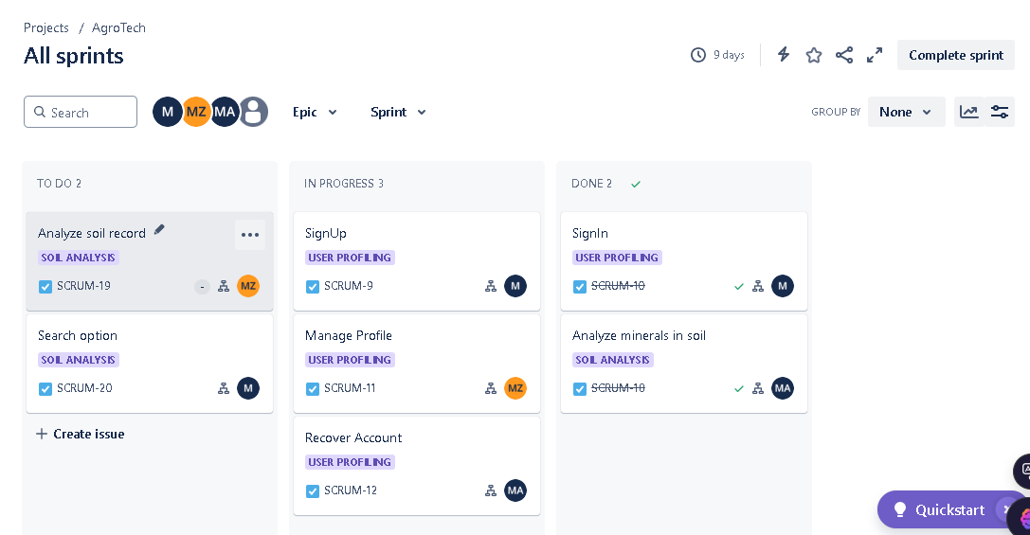

**Backlog with Epics, Stories:**

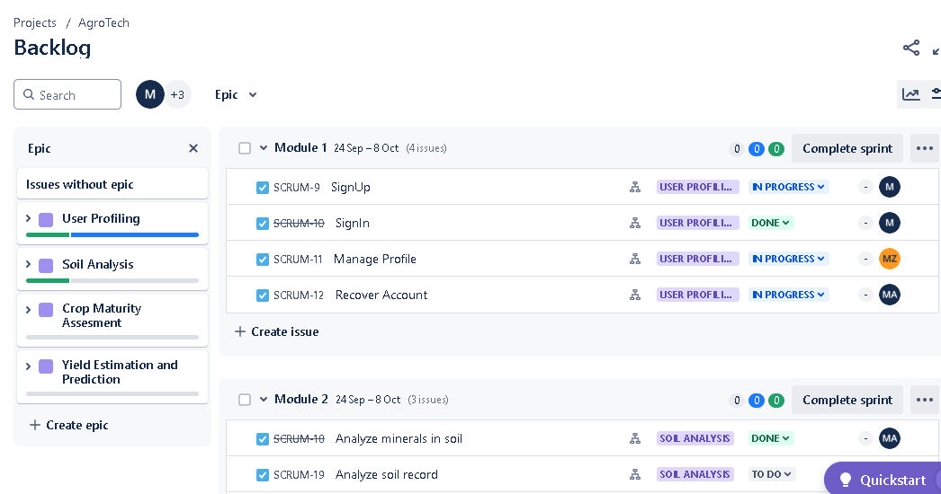

**Project Timeline:**

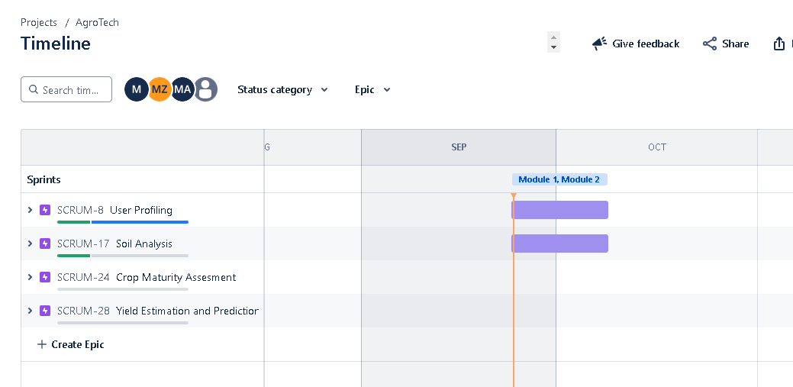

**Burnup Chart for issue count:**

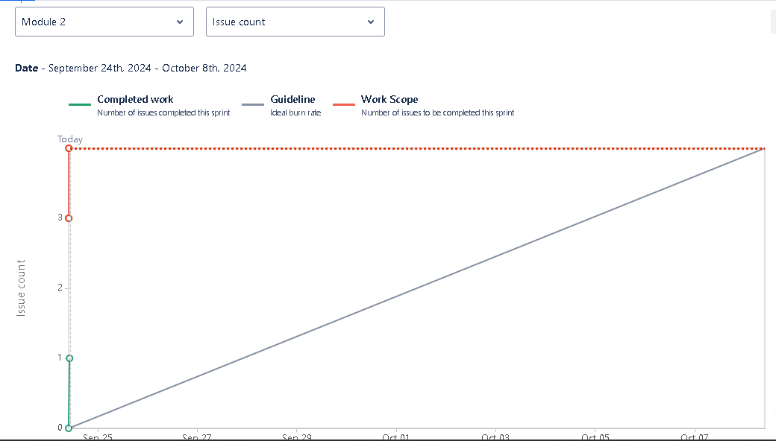

**Cumulative Chart:**

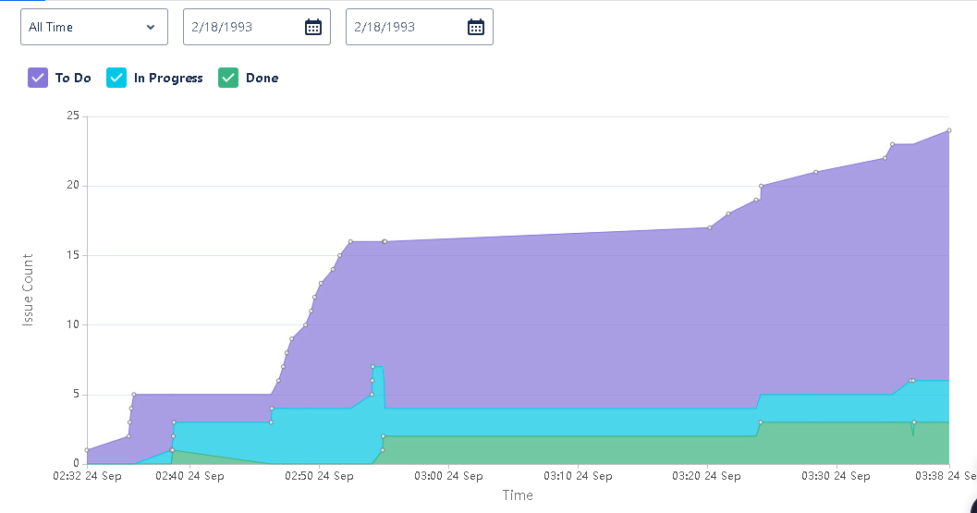

**Burndown chart:**

